Programming Assignment 2: Program 1 Documentation
- Problem Statement
Create and implement three classes, then use a driver function to test them. For the testing, write and use each of the writing a class with methods. Then use the main to combine and test all the components together.

- Requirements
  - Assumptions
- Each class will have attributes
- Input set through code.
- Output will be handled by the command line

  - Specifications
- The program will contain 3 classes:
  - vehicle:
    - Attributes:
      - age – age of vehicle
      - price – price of vehicle
    - Behaviors
      - vehicle() – the default constructor sets age=0, and price=0.0
      - setAge() – it takes an integer parameter, returns nothing
      - setPrice() – it takes a float parameter, returns nothing
      - getAge() – it takes no parameters, returns the vehicle’s age
      - getPrice() – it takes no parameters, returns the vehicle’s price
  - car:
    - Attributes:
      - It has all the attributes of an object of type vehicle
      - raceCarStatus() – it is a boolean (true/false)
    - Behaviors
      - It has all the behaviors of an object type vehicle
      - car() – the default constructor sets raceCarStatus = false
      - setRaceCarStatus() – takes boolean parameter, returns nothing
      - getRaceCarStatus() – takes no parameters, returns car’s race car status
  - truck
    - Attributes:
      - It has all the attributes of an object of type vehicle
      - dieselTypeStatus – it is a boolean
    - Behaviors:
      - truck() – the default constructor sets dieselTypeStatus = false
      - setDieselTypeStatus() = takes boolean parameter, returns nothing
      - getDieselTypeStatus() = takes no parameters, returns Truck’s diesel type status
- Decomposition Diagram
- Program 1
  - Input
    - Program takes inputs from the main .cpp file
  - Process
    - Functions listed under specifications under classes can be called
  - Output
    - Program will print out the results onto the command line via usage of the print function

Class vehicle
Responsibilities:  +age  +price  +vehicle()  +setAge()  +setPrice()  +getAge()  +getPrice() | Collaborators: N/A

Class car
Responsibilities:  +age  +price  +raceCarStatus  +car()  +setAge()  +setPrice()  +getAge()  +getPrice()  +setRaceCarStatus()  +getRaceCarStatus() | Collaborators: N/A

Class truck
Responsibilities:  +age  +price  +dieselTypeStatus  +truck()  +setAge()  +setPrice()  +getAge()  +getPrice()  +setDieselTypeStatus()  +getDieselTypeStatus() | Collaborators: N/A

- Test Strategy
- Valid Data
- Invalid Data

- Test Plan Version 1
Test Strategy | Test Number | Description | Input | Expected Output | Actual Output | Pass/Fail
Valid Data | 1 | Testing truck Diesel Type Status
Valid Data | 2 | Testing Race Car Status
Invalid Data | 3 | Testing setting and getting Age of car
Invalid Data | 4 | Testing setting and getting Age of truck

- Initial Algorithm
- Class:
  - Vehicle
    - vehicle()
      - This will set up the object vehicle
      - Set the age and price to default of 0
    - setAge()
      - It will take in an integer
      - It will return nothing
    - setPrice()
      - It will take in an float
      - It will return nothing
    - getAge()
      - It will take no parameters
      - It will return the vehicle’s age
    - getPrice()
      - It will take no parameters
      - It will return the vehicle’s price
  - Car
    - raceCarStatus
      - A boolean that states the status of the racecar
      - Set the raceCarStatus to default false
    - car()
      - It will create a car
    - setAge()
      - It will take in an integer
      - It will return nothing
    - setPrice()
      - It will take in an float
      - It will return nothing
    - getAge()
      - It will take no parameters
      - It will return the car’s age
    - getPrice()
      - It will take no parameters
      - It will return the car’s price
    - setRaceCarStatus()
      - It will set the raceCarStatus
      - It will return nothing
    - getRaceCarStatus()
      - It will take no parameters
      - It will return the raceCar’s status
  - Truck
    - dieselTypeStatus
      - A boolean that states the status of the truck
    - truck()
      - It will create a car
      - Set the raceCarStatus to default false
    - setAge()
      - It will take in an integer
      - It will return nothing
    - setPrice()
      - It will take in an float
      - It will return nothing
    - getAge()
      - It will take no parameters
      - It will return the truck’s age
    - getPrice()
      - It will take no parameters
      - It will return the truck’s price
    - setDieselTypeStatus()
      - It will set the Diesel Type status
      - It will return nothing
    - getDieselTypeStatus()
      - It will take no parameters
      - It will return the truck’s Diesel Type status

- Test Plan Version 2
Test Strategy | Test Number | Description | Input | Expected Output | Actual Output | Pass/Fail
Valid Data | 1 | Testing truck Diesel Type Status | setDieselTypeStatus();  getDieselTypeStatus();
Valid Data | 2 | Testing Race Car Status | setRaceCarStatus();  getRaceCarStatus();
Invalid Data | 3 | Testing setting and getting Age of car | car::setAge();  car::getAge();
Invalid Data | 4 | Testing setting and getting Age of truck | truck::setAge();  truck::getAge();

- Code
Main
//Programmer Name: Srinivas Simhan
//Program Name: Programming Assignment 2 - Program 1 [PA2_P1.cpp]
//Purpose of Program: This main file will test the parent class (vehicle), along with two subclasses (truck & car)
//Last Modified Date: October 23, 2017
//Date Due: October 23, 2017

#include <iostream>
#include "PrimaryClasses.h"
using namespace std;

void main() {
vehicle v = vehicle();
v.setAge(5);
v.setPrice(4.69);
v.getAge();
v.getPrice();

car c = car();
c.setAge(5);
c.setPrice(48.69);
c.setRaceCarStatus(true);
c.getAge();
c.getPrice();
c.getRaceCarStatus();

truck t = truck();
t.setAge(5);
t.setPrice(459.69);
t.setDieselTypeStatus(true);
t.getAge();
t.getPrice();
t.getDieselTypeStatus();
}

Header
#pragma once

//Programmer Name: Srinivas Simhan
//Program Name: Programming Assignment 2 - Program 1 [PrimaryClasses.h]
//Purpose of Program: This program will define the parent class (vehicle), along with two subclasses (truck & car)
//Last Modified Date: October 23, 2017
//Date Due: October 23, 2017

#ifndef PRIMARYCLASSES_H
#define PRIMARYCLASSES_H

#include <iostream>
using namespace std;

class vehicle
{
//Set Behaviors
public:
vehicle() {
age = 0;
price = 0.0;
}

void setAge(int age) {
this->age = age;
}

void setPrice(float price) {
this->price = price;
}

int getAge() {
return age;
}

int getPrice() {
return price;
}

//Set Attributes
private:
int age;
float price;
};

class car:public vehicle
{
//Set Behaviors
public:
car() {
setAge(0);
setPrice(0.0);
raceCarStatus = false;
}

void setRaceCarStatus(bool raceCarStatus) {
this->raceCarStatus = raceCarStatus;
}

bool getRaceCarStatus() {
return raceCarStatus;
}

//Set Attributes
private:
bool raceCarStatus;
};

class truck :public vehicle
{
//Set Behaviors
public:
truck() {
setAge(0);
setPrice(0.0);
dieselTypeStatus = false;
}

void setDieselTypeStatus(bool dieselTypeStatus) {
this->dieselTypeStatus = dieselTypeStatus;
}

bool getDieselTypeStatus() {
return dieselTypeStatus;
}

//Set Attributes
private:
bool dieselTypeStatus;
};

#endif

- Updated Algorithm
- Class:
  - Vehicle
    - Public:
      - vehicle()
        - This will set up the object vehicle
        - Set the age and price to default of 0
      - setAge()
        - It will take in an integer for age
        - It will take the age integer and set it to the object as it’s age
          - (this->age = age)
      - setPrice()
        - It will take in an float for price
        - It will take the price float and set it to the object as it’s price
          - (this->price = price)
      - getAge()
        - It will take no parameters
        - It will return the vehicle’s age
      - getPrice()
        - It will take no parameters
        - It will return the vehicle’s price
    - Private:
        - age is set as an integer type variable
        - price is set as a float type variable

  - Car
    - It will inherit the functions from the public portion of the vehicle class
    - Public:
      - car()
        - It will create a car object
        - It will use the setAge function and set it to 0
        - It will use the setPrice function and set it to 0.0
        - It will set the initial raceCarStatus to false
      - raceCarStatus
        - A boolean that states the status of the racecar
        - Set the raceCarStatus to default false
        - It will take the raceCarStatus boolean and set it to the object as it’s raceCarStatus
          - (this->raceCarStatus = raceCarStatus)
      - setAge()
        - It will take in an integer for age
        - It will take the age integer and set it to the object as it’s age
          - (this->age = age)
      - setPrice()
        - It will take in an float for price
        - It will take the price float and set it to the object as it’s price
          - (this->price = price)
      - getAge()
        - It will take no parameters
        - It will return the car’s age
      - getPrice()
        - It will take no parameters
        - It will return the car’s price
      - setRaceCarStatus()
        - It will set the raceCarStatus
        - It will return nothing
      - getRaceCarStatus()
        - It will take no parameters
        - It will return the raceCar’s status
    - Private:
      - bool raceCarStatus()
        - This is to set raceCarStatus as a boolean type variable
  - Truck
    - It will inherit the functions from the public portion of the vehicle class
    - Public:
    - dieselTypeStatus
      - A boolean that states the status of the truck
    - truck()
      - It will create a car
      - Set the raceCarStatus to default false
    - setAge()
      - It will take in an integer for age
      - It will take the age integer and set it to the object as it’s age
        - (this->age = age)
    - setPrice()
      - It will take in an float for price
      - It will take the price float and set it to the object as it’s price
        - (this->price = price)
    - getAge()
      - It will take no parameters
      - It will return the car’s age
      - getPrice()
      - It will take no parameters
      - It will return the car’s price
    - setDieselTypeStatus()
      - It will set the Diesel Type status
      - It will return nothing
    - getDieselTypeStatus()
      - It will take no parameters
      - It will return the truck’s Diesel Type status
    - Private:
      - getDieselTypeStatus()
      - This is to set getDieselTypeStatus as a boolean type variable

- Test Plan Version 3
Major changes were made to incorporate the main.cpp.
Test Strategy | Test Number | Description | Input | Expected Output | Actual Output | Pass/Fail
Valid Data | 1 | Testing vehicle Age | v.setAge(5);  v.getAge(); | Age is 5 | Age is 5 | Pass
Valid Data | 2 | Testing vehicle Price | v.setPrice(4.69);  v.getPrice(); | Price is 4.69 | Price is 4.69 | Pass
Valid Data | 3 | Testing car RaceCarStatus functions | c.setRaceCarStatus(true);  c.getRaceCarStatus(); | RaceCarStatus is true | RaceCarStatus is true | Pass
Valid Data | 4 | Testing truck DieselTypeStatus | t.setDieselTypeStatus(true);  t.getDieselTypeStatus(); | DieselTypeStatus is true | DieselTypeStatus is true | Pass
Valid Data | 5 | Testing car Age (inherited vehicle) | c.getAge(); | Age is 6 | Age is 6 | Pass
Valid Data | 6 | Testing car Price (inherited vehicle) | c.getPrice(); | Price is 48.69 | Price is 48.69 | Pass
Valid Data | 7 | Testing truck Age (inherited vehicle) | t.getAge(); | Age is 7 | Age is 7 | Pass
Valid Data | 8 | Testing truck Price (inherited vehicle) | t.getPrice(); | Price is 459.69 | Price is 459.69 | Pass
Invalid Data | 9 | Testing Truck Age (inherited vehicle) | t.setAge(asdf); | Age is asdf | “ERROR” | Pass
Invalid Data | 10 | Testing truck Price (inherited vehicle) | t.setPrice(asdfadsf); | Price is asdfadsf | “ERROR | Pass

- Screenshots
1, 2
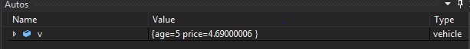

3, 5, 6
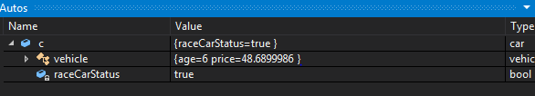

4, 7, 8
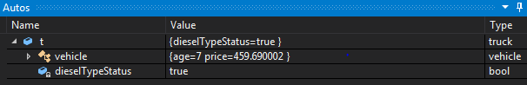

9, 10
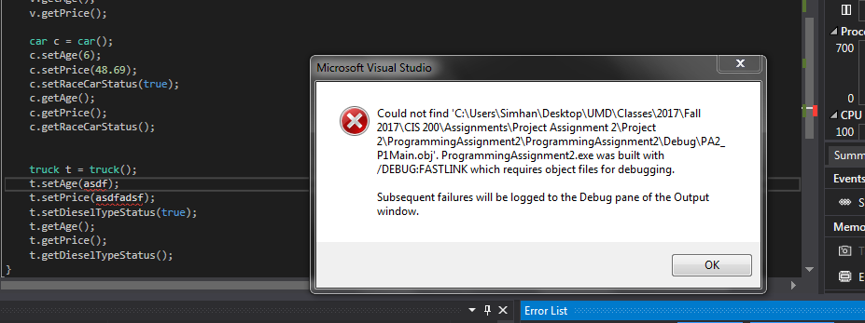
- Error Log
Error Type | Cause of Error | Solution to Error
None | N/A | N/A

- Status
Program is working well and could potentially use more fine tuning.

